Type of Article: Regular paper/Short report/Review articles/Information articles/Material for research work/Field report

Title: Titles should be typed in bold font and the initial letters of every word except prepositions and conjunctions should be capitalized.

Running title: Running title should not exceed 50 letters, and should not be in bold or capitals.

Authors: name Abc^{1*}, name Def², and name Ghi¹
Affiliated Institution:
¹ Faculty of AAA, University of XXX, Street address, City/Ward, Prefecture Postal code, Country
² Faculty of BBB, YYY University, Street address, City/Ward, Prefecture Postal code, Country

*Corresponding author
xxxxx@yyy.ac.jp

Keywords: Keywords, excluding those for short reports, should consist of 6 words or less, and 3 words or less for short reports.

Abstract
Write from here……Abstract for regular paper should be within 240 words.
Short report and field report do not require abstracts.

Introduction
Write from here…...

Material and Methods
Category name1
Main text from here……

Category name2
One level smaller category name
*The headlines of third categories, if any, are to be in italics and left-aligned.
Main text from here……

Results
Category name3
Main text from here……

Category name4
One level smaller category name
*The headlines of third categories, if any, are to be in italics and left-aligned.
Main text from here……

Discussion
Main text from here……

Acknowledgement
Main text from here……

References
1. List all cited references without distinguishing between content types, in alphabetical order by author name. (Periodicals/Books/Web).
2. References by the same first authors must be arranged in the alphabetical order of second authors.
3. References by the same authors must be arranged in chronologically.
4. For the references by the same authors and published in the same year, the letters “a”, “b”, etc. must be added following the year to distinguish these from others in the main text.
5. Non-English literature must have the language specified in parentheses as follow: (in Vietnames with French summary).
6. Accepted articles that have not yet been published can be cited and must be noted as “in press”.

References should be listed as follows:
[i-a] Periodicals-paper published
Richter, M., H. George, and G. W. Turner 2012. Effects of summer pruning on winter growth of atemoya cv. Jeffner. Jpn. J. Trop. Agr. 5: 233-238.
Williams, A. L., C. Johnson, and J. Smith 2012. Traditionalagriculture in the Philippines: A progress report. Trop. Agr. Develop. 45:. (in press)
Yamada, T., T. Endo, and I. W. Harper 2012a. Yield compo-nents of rain-fed paddy fields in Northeast Thailand. Hawaii Agr. Exp. St. Tech. Bull. 179: 1134-1142.
Nguen, T. V. 2009. Effects of paclobutrazol in off-season flower induction of 'Kho qua xanh' durian. Proceedings of the 13th Symposium on Fruit Production in the Mekong Delta. Hue University (Vietnam) Dec.15-18, 2008. pp. 10-12. (in Vietnamese with French summary)

[i-b] Periodicals-online journal
Bagwasi, G., G. A. Agenbag, and P. A. Swanepoel. 2020. Effect of salinity on the germination of wheat and barley in South Africa. Crop Forage Turfgrass Manag. 6. 1: e20069.

[ii] Books
Food and Agriculture Organization of the United Nations (FAO). 2009. Production Yearbook. Vol. 45. FAO(Rome) p. 120.
Martin, J. P., E. L. Bernard, and R. T. Dubois 2010.Productivity of root and tuber crops in tropical wet-land. In: Plants and People in Asia. (Moreau, W. C. ed.) Lutetia Academic Press (Paris) pp. 225-230.
Morton, J. F. 1987. Mango. In: Fruits of Warm Climates. Julia F. Morton (Miami) pp. 221-239.
[iii] Web content
World Health Organization (WHO) 2012. Chapter 1. Guideline for drinking-water quality. In: World Situation for Water Management. pp. 5-12. [Online] http://www.who.int/water_sanitation_health.pdf (browsed on May 15, 2012)

For short reports, the titles of periodicals should not be written:
Richter, M., H. George, and G. W. Turner 2012. Jpn. J. Trop. Agr. 5: 233-238.
Williams, A. L., C. Johnson, and J. Smith 2012. Trop. Agr. Develop. 45:. (in press)
Yamada, T., T. Endo, and I. W. Harper 2012a. Hawaii Agr. Exp. St. Tech. Bull. 179: 1134-1142.
Nguen, T. V. 2009. Proceedings of the 13th Symposium on Fruit Production in the Mekong Delta. Hue University (Vietnam) Dec. 15-18, 2008. pp. 10-12. (in Vietnamese with French summary)

* Insert figure and table here (after inserting a page break following the text)
** One figure or table per page.
*** Tables and Figures should be showed as follows:

Tables.
Table 1. Xxxxxx.
line title |  | Treatment(℃)
line title |  | 10 | 15 | 20
a | * | 1 | 5 | 3
 | ** | 10 | 20 | 15
b | * | 1 | 10 | 5
 | ** | 10 | 50 | 25
c | * | 0 | 1 | -
 | ** | 0 | 10 | -

Figures
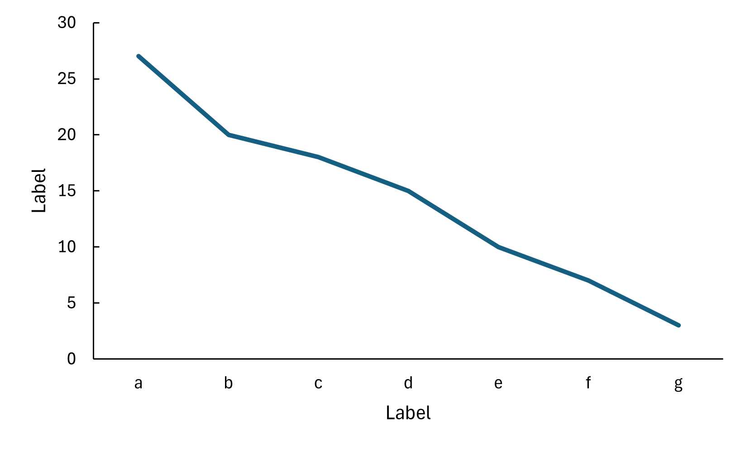
Fig. 1. Xxxxxx.

